Partial / residual correlation: AUDUSD and EURGBP
Method 07 / daily log returns / leave-currency-out USD factor / Alpari D1 full available history

Study setup
Logical pair: AUDUSD , EURGBP
Broker symbols: AUDUSD_i , EURGBP_i
Snapshot: 2026-11-03_majors_alpari_D1
Timeframe: D1
Matched return window: 1999-01-06 to 2026-11-02 (UTC bar dates)
Matched return count n: 7129
Dropped unfinished last bar dated 2026-11-03 UTC after a tick-volume check against the prior complete day.
USD-strength sign rule: minus log return when USD is the quote (EURUSD, GBPUSD, AUDUSD, NZDUSD); plus log return when USD is the base (USDJPY, USDCHF, USDCAD). EURGBP is never a constituent.
Control z constituents (4): NZDUSD, USDJPY, USDCHF, USDCAD
z_t = equal-weight mean of those USD-strength returns on the same day
Complete matched rows (Excel): AUDUSD-EURGBP_Partial_D1.xlsx
Complete matched rows (HTML table): AUDUSD-EURGBP_Partial_D1_data.html

Method carried forward
Partial / residual correlation regresses each matched daily log return of close, ln(close_t / close_t-1), on the same leave-currency-out USD strength factor z, then takes Pearson correlation of the two residual series. Quotes are not inverted. z is the equal-weight mean of USD-strength returns from other majors that do not share a non-USD currency with either leg; EURGBP is never a constituent. USD-strength is minus the log return when USD is the quote (EURUSD, GBPUSD, AUDUSD, NZDUSD) and plus the log return when USD is the base (USDJPY, USDCHF, USDCAD). OLS uses an intercept on each leg. rho_partial is symmetric under swap of the two symbols. It describes leftover linear co-movement after removing linear z; it is not a cause, not a lead, and not a trading signal. Daily rows are not independent and residuals are estimated, so the two-sided p-value and Fisher interval are secondary. Same-sample raw Pearson r is a side check only.

Regression on z
leg | intercept_a_or_c | slope_b_or_d | R2
AUDUSD | 1.746e-05 | -1.1984814 | 0.50484871
EURGBP | 2.159e-05 | -0.20030112 | 0.03389127

Results
rho_partial: -0.136336
Two-sided p-value: 6.32352e-31
Approximate 95% Fisher interval: [-0.159046, -0.113481]
Same-sample raw Pearson r: 0.036509
rho_partial minus r: -0.172845

Conclusion
Over 7129 matched daily rows for AUDUSD and EURGBP after removing a leave-currency-out USD factor built from 4 constituents, rho_partial is -0.1363 (negative, weak residual linear link in this sample). Approximate 95% Fisher interval: [-0.1590, -0.1135]. Same-sample raw Pearson r is 0.0365 (partial minus r = -0.1728). Leg R-squared on z: AUDUSD=0.5048, EURGBP=0.0339. Two-sided p under the usual independent-pairs model is 6.324e-31; residuals are estimated and daily FX rows are linked, so treat p as secondary. This does not establish cause, lead-lag, or a lasting trading rule.

Charts
Daily closes
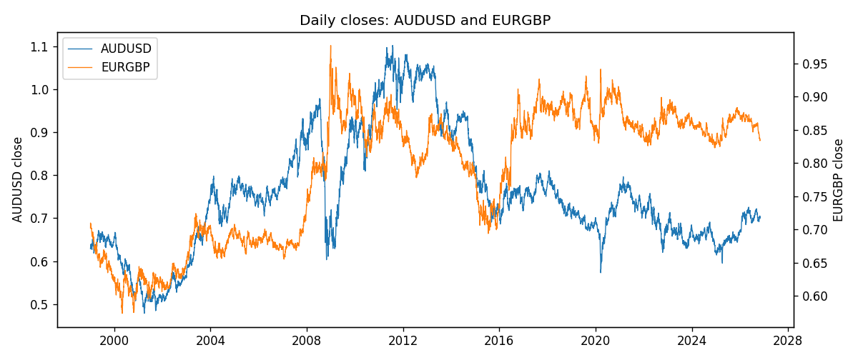
Log returns and control z
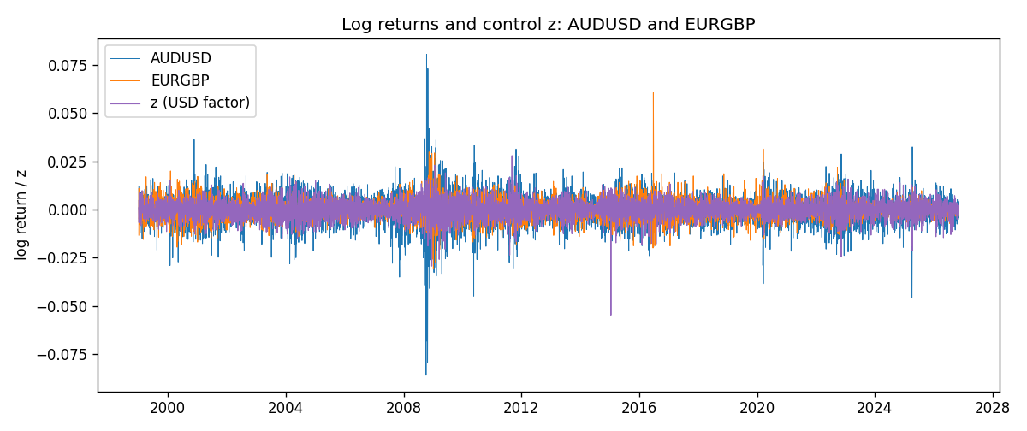
Residual scatter e_x vs e_y
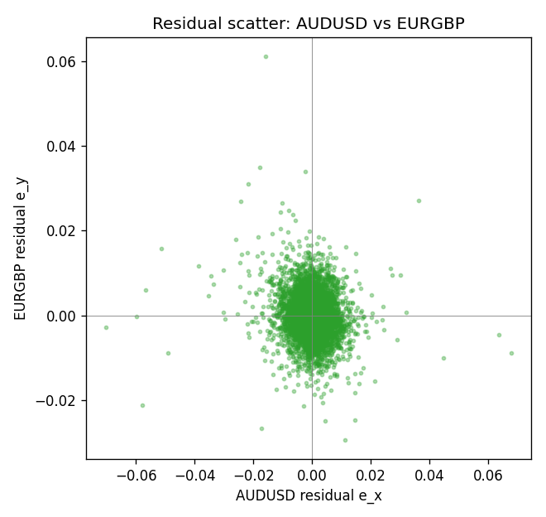

Data report
Every matched row that entered the partial correlation is stored in the sibling Excel workbook named AUDUSD-EURGBP_Partial_D1.xlsx. That file is the complete data archive for redrawing charts. Embedding all rows as a Word table is impractical at this length; the Word file holds the column list, column summaries, and the first and last 15 matched rows.
Columns: time, AUDUSD_open, EURGBP_open, AUDUSD_high, EURGBP_high, AUDUSD_low, EURGBP_low, AUDUSD_close, EURGBP_close, AUDUSD_tick_volume, EURGBP_tick_volume, AUDUSD_spread, EURGBP_spread, AUDUSD_real_volume, EURGBP_real_volume, AUDUSD_log_return, EURGBP_log_return, usd_strength_NZDUSD, usd_strength_USDJPY, usd_strength_USDCHF, usd_strength_USDCAD, z, AUDUSD_fitted, EURGBP_fitted, AUDUSD_resid, EURGBP_resid
Column summaries (matched calculation rows)
column | count | mean | std | min | 25% | 50% | 75% | max
AUDUSD_open | 7129 | 0.75283663 | 0.13529527 | 0.4785 | 0.6616 | 0.732 | 0.8128 | 1.10284
EURGBP_open | 7129 | 0.78787915 | 0.09637748 | 0.5734 | 0.6884 | 0.83444 | 0.8655 | 0.9769
AUDUSD_high | 7129 | 0.75689795 | 0.13585339 | 0.4878 | 0.66568 | 0.73559 | 0.8192 | 1.10795
EURGBP_high | 7129 | 0.79096121 | 0.09675282 | 0.5789 | 0.6905 | 0.83739 | 0.86841 | 0.9799
AUDUSD_low | 7129 | 0.7487795 | 0.13460671 | 0.4775 | 0.65842 | 0.72811 | 0.80696 | 1.0975
EURGBP_low | 7129 | 0.78517685 | 0.09619509 | 0.5682 | 0.6863 | 0.83221 | 0.86303 | 0.9661
AUDUSD_close | 7129 | 0.75289377 | 0.13527485 | 0.4786 | 0.66173 | 0.73217 | 0.81283 | 1.10169
EURGBP_close | 7129 | 0.78792406 | 0.09637588 | 0.5735 | 0.6884 | 0.83444 | 0.86555 | 0.977
AUDUSD_tick_volume | 7129 | 78085.706 | 138634.98 | 109 | 5640 | 43984 | 71730 | 1234623
EURGBP_tick_volume | 7129 | 87747.814 | 145877.32 | 332 | 6718 | 44856 | 82002 | 1424684
AUDUSD_spread | 7129 | 30.65984 | 16.886945 | 0 | 13 | 30 | 50 | 50
EURGBP_spread | 7129 | 21.135222 | 19.050893 | 0 | 4 | 13 | 40 | 50
AUDUSD_real_volume | 7129 | 5.2950336e+09 | 1.2601102e+11 | 0 | 0 | 0 | 0 | 3.811512e+12
EURGBP_real_volume | 7129 | 2.8078235e+10 | 1.3570431e+11 | 0 | 0 | 0 | 0 | 3.5726265e+12
AUDUSD_log_return | 7129 | 3.429e-05 | 0.00755471 | -0.08602525 | -0.00384986 | 0.00029309 | 0.004155 | 0.0806166
EURGBP_log_return | 7129 | 2.44e-05 | 0.00487311 | -0.03067367 | -0.00262262 | -9.978e-05 | 0.00256826 | 0.06075387
usd_strength_NZDUSD | 7129 | -2.603e-05 | 0.00764647 | -0.05966839 | -0.0045915 | -0.00024088 | 0.00423176 | 0.07027433
usd_strength_USDJPY | 7129 | 5.124e-05 | 0.0062132 | -0.03908203 | -0.00320044 | 0.00012446 | 0.00340927 | 0.05184024
usd_strength_USDCHF | 7129 | -7.228e-05 | 0.00659123 | -0.19545699 | -0.00334859 | 7.816e-05 | 0.00331593 | 0.09051364
usd_strength_USDCAD | 7129 | -9.1e-06 | 0.00514798 | -0.03859748 | -0.00283484 | 5.567e-05 | 0.00272835 | 0.03436319
z | 7129 | -1.404e-05 | 0.00447886 | -0.05478791 | -0.00255238 | 1.433e-05 | 0.00261581 | 0.0280526
AUDUSD_fitted | 7129 | 3.429e-05 | 0.00536782 | -0.03360307 | -0.00311754 | 2.8e-07 | 0.00307644 | 0.06567974
EURGBP_fitted | 7129 | 2.44e-05 | 0.00089712 | -0.00559738 | -0.00050236 | 1.872e-05 | 0.00053283 | 0.01099567
AUDUSD_resid | 7129 | 0 | 0.00531602 | -0.07010156 | -0.00240572 | 0.00015903 | 0.0026527 | 0.06764627
EURGBP_resid | 7129 | -0 | 0.00478982 | -0.02942989 | -0.0026556 | -0.0001341 | 0.00251799 | 0.06123281
First 15 matched rows (selected columns)
time | AUDUSD_close | EURGBP_close | AUDUSD_log_return | EURGBP_log_return | z | AUDUSD_fitted | EURGBP_fitted | AUDUSD_resid | EURGBP_resid
1999-01-06 | 0.6289 | 0.7019 | 0.011836351 | -0.013303338 | 0.0046988575 | -0.0056140382 | -0.00091959697 | 0.017450389 | -0.012383741
1999-01-07 | 0.6345 | 0.7097 | 0.0088650256 | 0.011051402 | -0.0067540186 | 0.0081120206 | 0.0013744269 | 0.00075300504 | 0.0096769749
1999-01-08 | 0.6347 | 0.7062 | 0.00031515916 | -0.004943862 | 0.0011931811 | -0.0014125503 | -0.00021740606 | 0.0017277095 | -0.004726456
1999-01-11 | 0.6393 | 0.7053 | 0.0072213815 | -0.0012752393 | -0.0061758264 | 0.0074190679 | 0.0012586144 | -0.00019768647 | -0.0025338536
1999-01-12 | 0.6362 | 0.7077 | -0.0048608485 | 0.0033970309 | 0.0086045062 | -0.010294885 | -0.0017019028 | 0.005434037 | 0.0050989336
1999-01-13 | 0.6312 | 0.708 | -0.0078902098 | 0.00042381861 | 0.0010984655 | -0.0012990354 | -0.00019843442 | -0.0065911744 | 0.00062225303
1999-01-14 | 0.6295 | 0.7066 | -0.002696916 | -0.0019793588 | 0.0011744087 | -0.0013900519 | -0.00021364593 | -0.0013068641 | -0.0017657128
1999-01-15 | 0.634 | 0.7012 | 0.007123101 | -0.0076715819 | 0.0046322488 | -0.0055342089 | -0.00090625516 | 0.01265731 | -0.0067653267
1999-01-18 | 0.6346 | 0.7017 | 0.00094592471 | 0.00071280921 | -6.370478e-05 | 9.3803995e-05 | 3.4349576e-05 | 0.00085212072 | 0.00067845963
1999-01-19 | 0.6392 | 0.7007 | 0.0072225153 | -0.0014261269 | -0.00120143 | 0.0014573465 | 0.0002622372 | 0.0057651688 | -0.0016883641
1999-01-20 | 0.64 | 0.7021 | 0.0012507819 | 0.0019960086 | -0.0020515152 | 0.0024761578 | 0.00043251022 | -0.0012253759 | 0.0015634984
1999-01-21 | 0.6405 | 0.7016 | 0.00078094498 | -0.00071240297 | -0.00092550925 | 0.0011266606 | 0.00020696997 | -0.00034571562 | -0.00091937294
1999-01-22 | 0.6327 | 0.7004 | -0.012252745 | -0.0017118406 | 0.005113539 | -0.0061110263 | -0.0010026581 | -0.0061417189 | -0.00070918251
1999-01-25 | 0.6302 | 0.6966 | -0.0039591468 | -0.0054402425 | -0.00012462764 | 0.0001668189 | 4.6552492e-05 | -0.0041259657 | -0.005486795
1999-01-26 | 0.6305 | 0.6962 | 0.00047592608 | -0.00057438255 | -0.00093935737 | 0.0011432573 | 0.00020974377 | -0.00066733124 | -0.00078412632
Last 15 matched rows (selected columns)
time | AUDUSD_close | EURGBP_close | AUDUSD_log_return | EURGBP_log_return | z | AUDUSD_fitted | EURGBP_fitted | AUDUSD_resid | EURGBP_resid
2026-10-13 | 0.69821 | 0.84458 | 0.0035007712 | 0.00020130374 | -0.0034402566 | 0.0041405385 | 0.00071067667 | -0.00063976732 | -0.00050937294
2026-10-14 | 0.69715 | 0.84553 | -0.0015193215 | 0.0011241873 | 0.002065939 | -0.0024585344 | -0.00039222045 | 0.00093921293 | 0.0015164077
2026-10-15 | 0.69191 | 0.84479 | -0.0075447063 | -0.00087557391 | -0.0050029 | 0.0060133375 | 0.0010236759 | -0.013558044 | -0.0018992498
2026-10-16 | 0.69426 | 0.84307 | 0.0033906408 | -0.0020380844 | -0.0032962877 | 0.0039679944 | 0.00068183954 | -0.00057735366 | -0.002719924
2026-10-19 | 0.6978 | 0.84259 | 0.0050859986 | -0.00056950988 | 0.00083865392 | -0.00098765611 | -0.00014639388 | 0.0060736547 | -0.000423116
2026-10-20 | 0.70022 | 0.83957 | 0.0034620426 | -0.0035906254 | -0.0030773304 | 0.0037055782 | 0.00063798215 | -0.00024353555 | -0.0042286076
2026-10-21 | 0.70275 | 0.83839 | 0.0036066384 | -0.00140647 | -0.00116709 | 0.0014161907 | 0.00025535888 | 0.0021904477 | -0.0016618289
2026-10-22 | 0.70186 | 0.83682 | -0.0012672558 | -0.0018743924 | -0.0031812773 | 0.0038301566 | 0.00065880283 | -0.0050974124 | -0.0025331952
2026-10-23 | 0.70353 | 0.83751 | 0.0023765656 | 0.00082421033 | 0.00073472193 | -0.00086309554 | -0.00012557618 | 0.0032396612 | 0.00094978651
2026-10-26 | 0.70128 | 0.83762 | -0.0032032829 | 0.00013133309 | 0.0022302926 | -0.0026555091 | -0.00042514065 | -0.00054777378 | 0.00055647374
2026-10-27 | 0.70245 | 0.83595 | 0.0016669876 | -0.0019957343 | 0.0020442907 | -0.0024325893 | -0.00038788426 | 0.0040995769 | -0.0016078501
2026-10-28 | 0.70533 | 0.83651 | 0.0040915541 | 0.00066967224 | 0.00097986439 | -0.0011568942 | -0.00017467849 | 0.0052484483 | 0.00084435074
2026-10-29 | 0.70245 | 0.83553 | -0.0040915541 | -0.0011722209 | -0.0014961816 | 0.0018106008 | 0.00032127628 | -0.0059021549 | -0.0014934972
2026-10-30 | 0.70316 | 0.83351 | 0.0010102376 | -0.0024205543 | -0.0003922382 | 0.00048754518 | 0.00010015519 | 0.00052269246 | -0.0025207095
2026-11-02 | 0.69971 | 0.83426 | -0.0049184984 | 0.00089940465 | -0.00032265898 | 0.00040415579 | 8.6218392e-05 | -0.0053226542 | 0.00081318626

